**CSCI 1100 – Fall 2016**

**Assignment 2 – Due Tuesday Nov. 15 at 11:00 pm (evening)**

**Submit on Brightspace**

**Name: Mihyar Al-Massalma**

**Student ID:** B00759975

**Assignments are to be your own work. If you have questions, you can ask your Instructor, course TAs, or TAs in the Learning Centre.**

|  |  |  |
| --- | --- | --- |
| **Declaration: Please complete this declaration** | | |
| 1 | “This document is entirely my own work.” If no, acknowledge any assistance below; outside help should only be used to help you understand the questions NOT to provide the solutions. | Yes |
| 2 | I obtained help to complete this document (e.g., from a TA). | No |
| 3 | This document contains some guidance from the Internet or another document or file or program (e.g., Java's API). | No |

*Your task is to complete this report using Word (or another word processing program) and JGrasp and to submit the complete Word document on Brightspace* ***saved******as a******pdf****. Read the questions carefully! Acknowledge any help that you obtained from your Lab or Learning Centre TAs in the table above.* ***Again note, assignments must be your own work****.*

* **Submit using Brightspace. Make sure you double check that the file has been added to Brightspace.**
* TAs can only provide help in understanding the problem and by giving other small hints.
* Make sure your programming code is neatly formatted and properly commented (you will lose marks for poor formatting and commenting).
* Also, be sure to provide the requested number of test outputs. Each test output must be different from the sample outputs given for each question.

**Exercise 1.** Write a program that asks a user to enter a number. Your program will then print out all the *positive factors* of that number (i.e., numbers that divide evenly into the number, leaving no remainder). See the sample code below. Use a while loop for this question. You should have 3 test cases (all different from the sample).

**Sample:**

Enter a number: 6

Factors: 1 2 3 6

Enter a number: 12

Factors: 1 2 3 4 6 12

Enter a number: 3

Factors: 1 3

/* Assignment2 Question 1  
This program will give back the factors of a number  
<CSCI 1100><Mihyar Al-Masalma><B00759975>*/  
import java.util.Scanner; // import Scanner class  
public class Q1 {  
 public static void main(String[] args) {  
 int counter = 1;  
 String result = "";  
 // Create an instance of the Scanner class  
 Scanner input = new Scanner(System.in);  
 // Ask the user to key-in a number  
 System.out.print("Enter a number: ");  
 // Store the number in a variable  
 int number = input.nextInt();  
 // Check the number starting from 1 to the number  
 while (number>=counter) {  
 // Check if the number is dividable   
 if (number%counter == 0) {  
 // Add the number to the result  
 result += counter;  
 // add a space between numbers  
 result += " ";  
 }  
 // Increase the counter  
 counter++;  
 }  
 // Print out the result   
 System.out.print("Factors: "+result);  
 }  
}

 ----jGRASP exec: java Q1  
▪Enter a number: 144  
▪Factors: 1 2 3 4 6 8 9 12 16 18 24 36 48 72 144   
 ----jGRASP: operation complete.

 ----jGRASP exec: java Q1  
▪Enter a number: 256  
▪Factors: 1 2 4 8 16 32 64 128 256   
 ----jGRASP: operation complete.

 ----jGRASP exec: java Q1  
▪Enter a number: 14  
▪Factors: 1 2 7 14   
 ----jGRASP: operation complete.

**Exercise 2.** Write a program that asks a user to enter a word. The program then tests to see if the word is the same spelled forward as backward (i.e., whether or not the word is a 'palindrome'). It prints a message indicating whether the word is a palindrome or not. Use a for loop. See the sample output below. You should have 3 test cases (all different from the samples provided here).

**Sample output:**

**//Shows when a word is a palindrome**

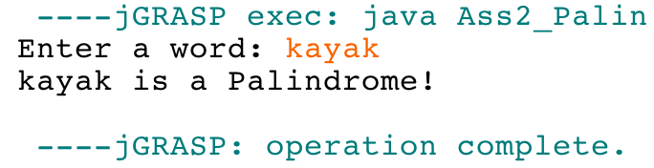

**//shows when a word is not a palindrome**

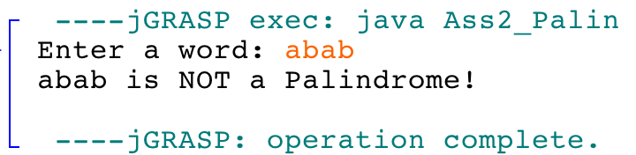

/* Assignment2 Question 2  
This program will reverse a given word and see if it is Palindrome  
<CSCI 1100><Mihyar Al-Masalma><B00759975>*/  
import java.util.Scanner; // import Scanner class  
public class Q2 {  
 public static void main(String[] args) {  
 String result="";  
 // Create an instance of the Scanner class  
 Scanner input = new Scanner(System.in);  
 // Ask the user to enter the word  
 System.out.print("Enter a word: ");  
 // Store the word in a variable  
 String word = input.nextLine();  
 // Convert the string to array of characters  
 char[] array = word.toCharArray();  
 // iterate over the array starting from the end  
 for (int i = array.length-1; i>=0 ;i-- ) {  
 // concat characters and assign it to result  
 result += array[i];  
 }  
 // if the words are teh same then print this out  
 if (word.equals(result)) {  
 System.out.print(word + " is a Palindrome!");  
 }else{  
 // if not equal print this out  
 System.out.print(word + " is NOT a Palindrome!");  
 }  
 }  
}

 ----jGRASP exec: java Q2  
▪Enter a word: tent  
▪tent is NOT a Palindrome!  
 ----jGRASP: operation complete.

 ----jGRASP exec: java Q2  
▪Enter a word: jeje  
▪jeje is NOT a Palindrome!  
 ----jGRASP: operation complete.

 ----jGRASP exec: java Q2  
▪Enter a word: racecar  
▪racecar is a Palindrome!  
 ----jGRASP: operation complete.

**Exercise 3.** Write a program that asks a user to enter in two words. The program prints a string consisting of the characters that are common to both the words (letters that are in both words). [You should look up the String method indexOf (char) in the Java API documentation to help you.] Repeated letters must be counted only once, and the order of common letters is not important. For example, if the Strings are abccd and ceccaa the value of the String returned by the method would be ac (order of characters not significant). Use a for loop. See Sample output below. You should have at least 3 test cases (different from the samples).

**Sample output:**

**//Shows when two words have common letters**

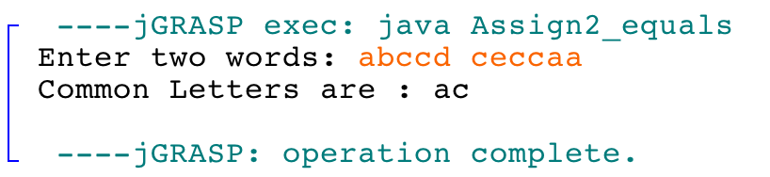

**//shows when two words have no letters in common**

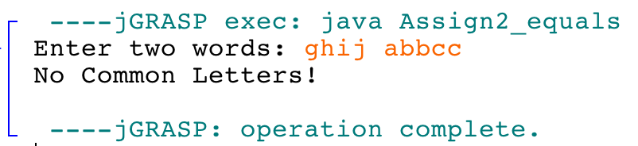

/* Assignment2 Question 3  
This program will give the common letters between two words  
without repetition  
<CSCI 1100><Mihyar Al-Masalma><B00759975>*/  
import java.util.Scanner; // import Scanner class  
public class Q3{  
 public static void main(String[] args) {  
 String result = "";  
 // Create an instance of Scanner class  
 Scanner input = new Scanner(System.in);  
 // Ask the user to enter two words  
 System.out.print("Enter two words: ");  
 // Store the words in two different variables  
 String firstWord = input.next();  
 String secondWord = input.nextLine();  
 // Assume the first word to be longer  
 int length = firstWord.length();  
 // Convert it to array  
 char[] array = firstWord.toCharArray();  
 // Assign secondWord to other  
 String other = secondWord;  
 // if our Assumption is wrong   
 if (secondWord.length()>length) {  
 // lenght is now the second word length  
 length = secondWord.length();  
 // Covert second word to array  
 array = secondWord.toCharArray();  
 // Assign first word to other  
 other = firstWord;  
 }  
 // iterate starting from 0 to the longer word  
 for (int i = 0; i< length; i++) {  
 // if the letter is in the other word  
 if (other.indexOf(array[i])>-1) {  
 // if it is not repeated  
 if (result.indexOf(array[i]) == -1) {  
 // Add it to the result   
 result += array[i];  
 }  
 }  
 }  
 // if there is no commin letters   
 if (result.equals("")) {  
 // Print out no common letters  
 System.out.print("No Common Letters!");  
 }else{  
 // if there are common letter print it out  
 System.out.print("Common Letters are :"+result);  
 }  
 }  
}

 ----jGRASP exec: java Q3  
▪Enter two words: Anna Jackson  
▪Common Letters are :an  
 ----jGRASP: operation complete.

 ----jGRASP exec: java Q3  
▪Enter two words: abcd dabc  
▪Common Letters are :dabc  
 ----jGRASP: operation complete.

 ----jGRASP exec: java Q3  
▪Enter two words: aaa bbb  
▪No Common Letters!  
 ----jGRASP: operation complete.

**Exercise 4.** Write a program that calculates the shipping fee for an online shoe store. The program will prompt the user to enter the number of pairs of shoes they wish to order. Then the program will ask the user to enter the cost of each pair of shoes. The program will calculate the total cost of the shoes and apply a shipping fee based on this total cost. The program will ask the customer to enter where they want to ship the order: Nova Scotia, Canada (excluding Nova Scotia), or Other (US/International). If the program does not recognize the shipping destination, the program will keep asking until the user enters a correct location. Then the program will determine an additional shipping fee based on where the customer wants to ship the order. For example, if the shoes are to be shipped within Nova Scotia there is no additional fee, but to send the order elsewhere in Canada would cost an additional $25. You can use for loops **or** while loops **or** a combination of both for this exercise. You **need** to generate correct a monetary output format (i.e. 2 decimal places) in this question. See the end of the assignment for a method (printf) that will help you control the places after the decimal.

See below for shipping costs:

Shipping fee based on cost:

An order that costs less than $100: 25% of the total

An order that costs between $100 dollars and $200: 15% of the total

Orders that cost more than $200: 10% of the total

Added shipping fee based on destination:

Shipping within Nova Scotia: no additional charge

Shipping elsewhere in Canada: $25.00

Shipping outside Canada: $50.00

**Some sample runs:**

**//Shows costs for three pairs of shoes being shipped to NS**

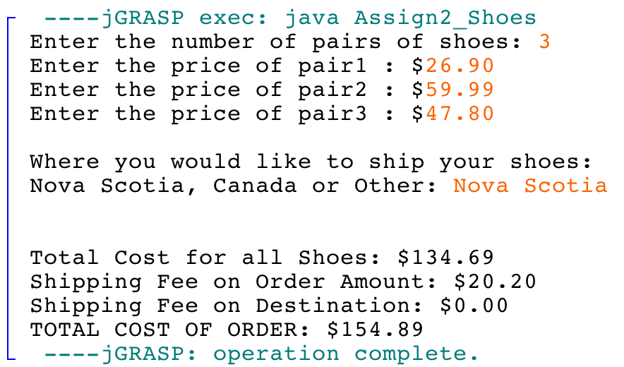

**//Shows cost of two pairs of shoes being shipped in Canada with a corrected location**

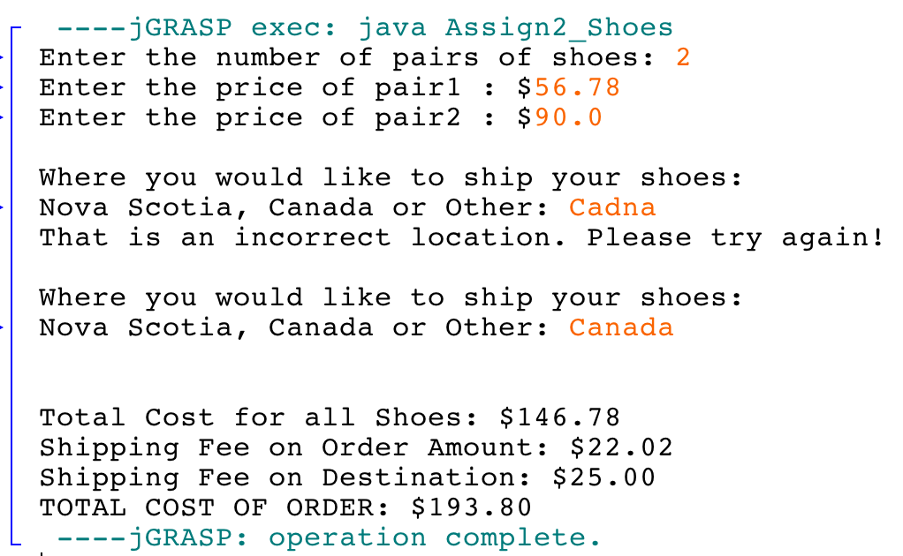

/* Assignment2 Question 4  
This program will take a number of goodies then  
calculate how much shipping you should pay and the total   
<CSCI 1100><Mihyar Al-Masalma><B00759975>*/  
import java.util.Scanner; // import Scanner class  
public class Q4 {  
 public static void main(String[] args) {  
 double price = 0, fees = 0, shippingFees = 0, total = 0;  
 String shipping = ""; int counter = 1;   
 // Create an instance of the Scanner class  
 Scanner input = new Scanner(System.in);  
 // Ask the user to enter a number and save it  
 System.out.print("Enter the number of pairs of shoes: ");  
 int number = input.nextInt();  
 // Iterate to get the prices and Store it in a variable  
 while (number >= counter) {  
 System.out.printf("Enter the price of pair%d : $", counter);  
 price += input.nextDouble();  
 counter++;  
 }  
 // Consume the rest of the line  
 input.nextLine();  
 // Iterate till the user enter valid Shipping destination  
 while (!shipping.equals("Nova Scotia") && !shipping.equals("Canada") && !shipping.equals("Other")) {  
 System.out.println("Where you would like to ship your shoes:");  
 System.out.print("Nova Scotia, Canada or Other: ");  
 shipping = input.nextLine();  
 }  
 // Print out in formated way the cost of the shoes  
 System.out.printf("Total Cost for all Shoes: $ %.2f",price);  
 // Based on the price, calculate the shipping fees  
 if (price < 100) {  
 fees = price * 0.25;  
 }else if (price < 200) {  
 fees = price * 0.15;  
 }else if (price > 200) {  
 fees = price * 0.10;  
 }  
 // Print out the shipping fees  
 System.out.printf("\nShipping Fee on Order Amount: $ %.2f", fees);  
 // based on the destination calculate the fees  
 if (shipping.equals("Canada")) {  
 shippingFees = 25;  
 }else if (shipping.equals("Other")) {  
 shippingFees = 50;  
 }  
 // print out the result in a formated way  
 System.out.printf("\nShipping Fee on Destination: $ %.2f", shippingFees);  
 total = price + fees + shippingFees;  
  
 System.out.printf("\nTOTAL COST OF ORDER: $ %.2f", total);  
 }  
}

 ----jGRASP exec: java Q4  
▪Enter the number of pairs of shoes: 3  
▪Enter the price of pair1 : $25.51  
▪Enter the price of pair2 : $26.32  
▪Enter the price of pair3 : $55.12  
▪Where you would like to ship your shoes:  
▪Nova Scotia, Canada or Other: Nova Scotia  
▪Total Cost for all Shoes: $ 106.95  
▪Shipping Fee on Order Amount: $ 16.04  
▪Shipping Fee on Destination: $ 0.00  
▪TOTAL COST OF ORDER: $ 122.99  
 ----jGRASP: operation complete.

 ----jGRASP exec: java Q4  
▪Enter the number of pairs of shoes: 2  
▪Enter the price of pair1 : $15.99  
▪Enter the price of pair2 : $99.9  
▪Where you would like to ship your shoes:  
▪Nova Scotia, Canada or Other: Cadna  
▪Where you would like to ship your shoes:  
▪Nova Scotia, Canada or Other: Canada  
▪Total Cost for all Shoes: $ 115.89  
▪Shipping Fee on Order Amount: $ 17.38  
▪Shipping Fee on Destination: $ 25.00  
▪TOTAL COST OF ORDER: $ 158.27  
 ----jGRASP: operation complete.

 ----jGRASP exec: java Q4  
▪Enter the number of pairs of shoes: 4  
▪Enter the price of pair1 : $11.9  
▪Enter the price of pair2 : $9.11  
▪Enter the price of pair3 : $14.5  
▪Enter the price of pair4 : $15.5  
▪Where you would like to ship your shoes:  
▪Nova Scotia, Canada or Other: Other  
▪Total Cost for all Shoes: $ 51.01  
▪Shipping Fee on Order Amount: $ 12.75  
▪Shipping Fee on Destination: $ 50.00  
▪TOTAL COST OF ORDER: $ 113.76  
 ----jGRASP: operation complete.

**Method printf (Textbook pp. 164-175)**

* Performs formatted output
* System.out.printf(formatString, argumentList)
* formatString is a string that contains text and/or formatting specifiers
* argument list is a list of zero or more additional arguments which are formatted to the specifiers listed in the formatString
* See the textbook for all the formats for output (e.g., %d is replaced with an int, %s is replaced with a String)

**Examples:**

int currYr=2016;

System.out.printf ("The current year is %d", currYr); //%d tells java to print an int

// this replaces the format "%d" with the int currYr

**Prints: The current year is 2016**

You can have more than one argument:

int age1=6;

int age2=8;

String name1="Sally";

String name2="Timmy";

System.out.printf("%s is %d and %s is %d years old.", name1, age1, name2, age2);//%s is a string

//matches the first %s with the first argument after the comma (name1)

**Prints: Sally is 6 and Timmy is 8 years old.**

You can format decimal places

double ave = 3.5678;

System.out.printf("The average is %.2f", ave); //%.2f is a decimal with 2 decimal places (rounded)

**Prints: The average is 3.57**